IOT Alcohol & Health Monitoring System

Factories, Offices, Hospitals, Military and other such industries need to monitor their staff/personnel follow all work ethics that include, not coming to premises under the influence of alcohol or under bad health conditions. This ensures proper work ethics are followed. So our proposed system allows for alcohol & health monitoring plus reporting system that monitors this and reports it to concerned personnel remotely over internet. Our system consists of an IOT based circuit system that uses a microcontroller based circuit system. The system has alcohol as well as blood pressure monitoring sensors to check for alcohol consumption as well as inappropriate blood pressure monitoring. This ensures no occurrences of accidents due to alcohol influence or bad health conditions.

Block Diagram :

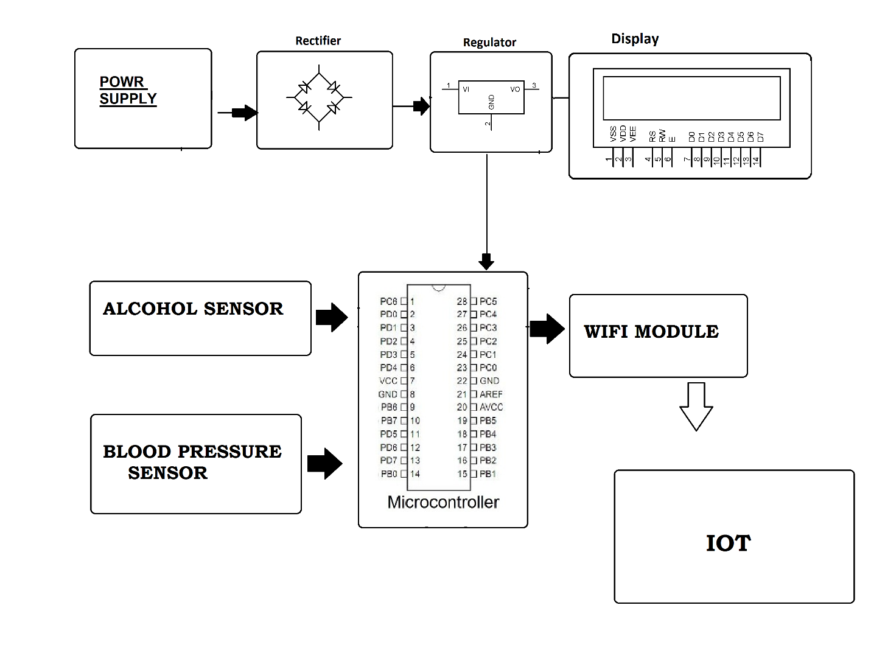

Hardware Specifications :
- Power Supply
- Rectifier
- Regulator
- LCD Display
- Alcohol Sensor
- Arduino Uno
- Blood Pressure Sensor
- Wifi Module
- IOT
Software Specifications :
- Arduino Compiler
- MC Programming Language: C

